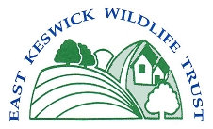

East Keswick Wildlife Trust Gift Aid

I would like the East Keswick Wildlife Trust to treat all donations and subscriptions I have made in the previous four years and any made from this date as Gift Aid donations until I notify you otherwise.

I am a UK taxpayer and understand that if I pay less Income Tax and/or Capital Gains Tax in the current tax year than the amount of Gift Aid claimed on all my donations it is my responsibility to pay any difference.

|  |  |
| --- | --- |
| Email Address |  |
| Full Name |  |
| Date |  |